# M1C2 UI/UX Assignment

*During this module, you have been introduced to UI/UX Development. UI/UX is used to make sure that applications are accessible and easily understood. You have been introduced to a variety of tools like sitemaps, wireframes, and color schemes, that help developers when they are working on user interfaces and user experiences. You will use a variety of those tools during this assignment. If you can’t remember how to build what is asked, refer back to the videos that explain each concept and try looking up examples. Please complete the following assignment and reach out on the Support App to have a mentor review your work. If you have any questions or need any help, please reach out so we can help you! This assignment must be completed to pass this section of the coursework.*

**Task One:** Referencing this image, create a low-fidelity wireframe.

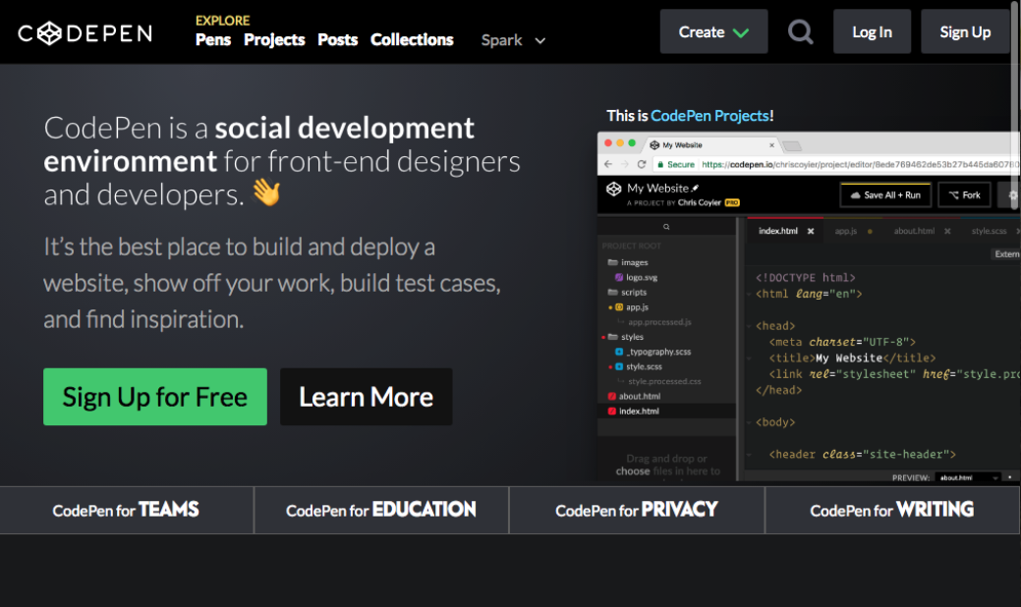

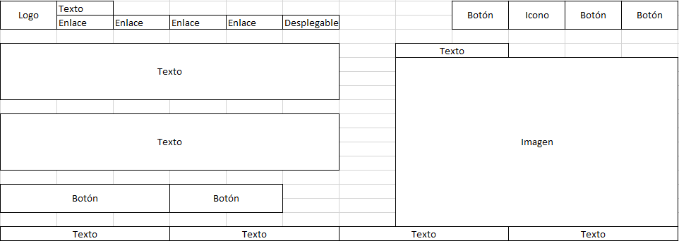

**Task Two:** Use one of the following websites and the inspect tool to identify 2-3 colors used repeatedly as part of the site’s color scheme. Remember that different shades of gray and black can be included as a color.

* <https://sebkay.com/>

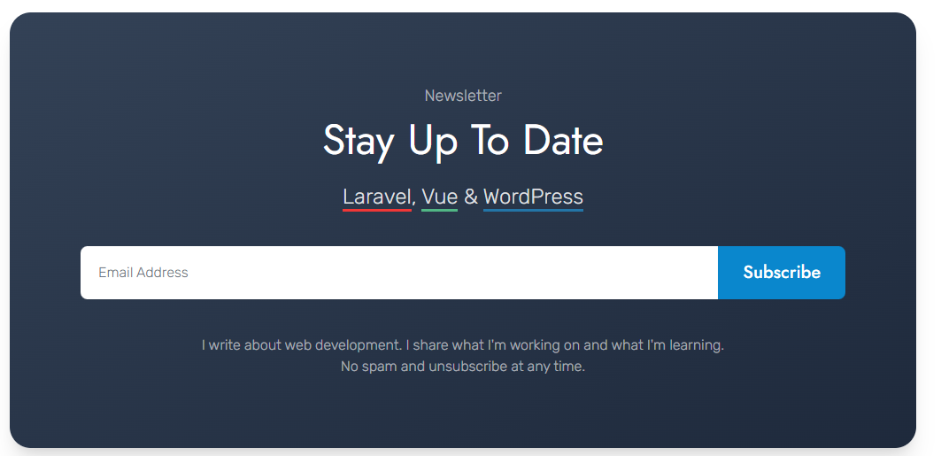

Esquina superior izquierda: #314158

Esquina inferior derecha: #1d293d

**Task Three:** Create a user story by referencing one of these websites

* Facebook <https://www.facebook.com/>

Accedo con mi usuario y contraseña. Me pongo a scrollear para abajo y veo que mi tía ha subido una foto con mi primo, la cual es una bonita foto con montañas alrededor. Le doy like y sigo scrollenado. Me aparece la foto de un buen amigo con su mujer y el bebe de ambos. Le doy like y les escribo un “A por todas pareja! ☺”. Sigo scrolleando hacia abajo pero no veo nada más de gran interés. Cierro la sesión.

**Task Four:** Identify the prime objective of Facebook, Twitter, Google, and Youtube.

* Facebook: Red social donde la gente comparte su vida con sus relaciones.
* Twitter: Red social donde la gente comparte opiniones con el resto de usuarios.
* Google: Herramienta de búsqueda de contenido.
* Youtube: Plataforma en la que los usuarios comparten vídeos con la comunidad.